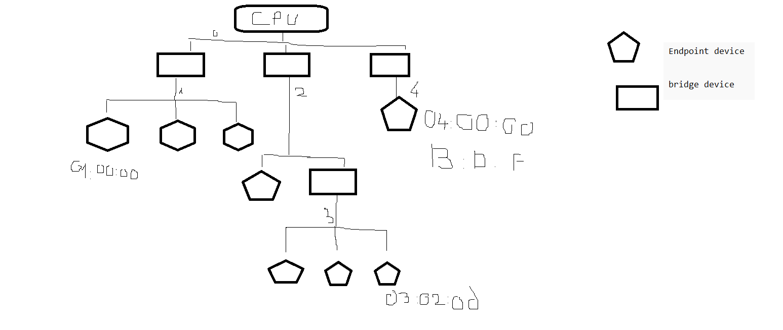
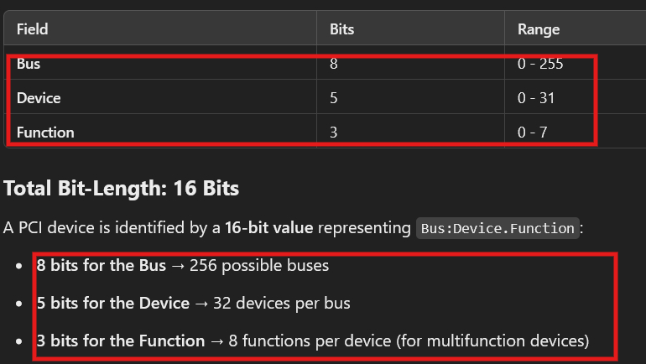

PCI vs PCIe
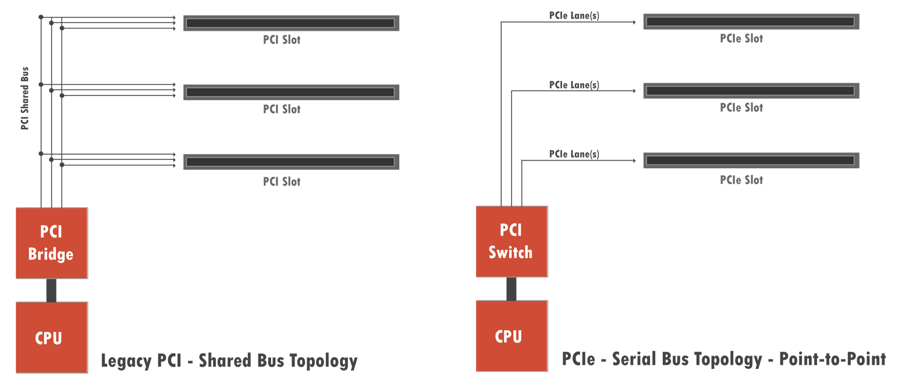
+ PCI shared bus – same bandwidth (In the same bus, it shared the same multiple wires)
+ PCIe lanes – different bandwidth (in the same bus, there are multiple lanes which each contains one or more (Tx, Rx))
PCIe lanes x4 -> 4 Tx and 4 Rx
PCIe lanes x16 -> 16 Tx and 16 Rx

